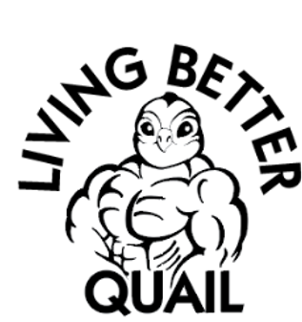
ALL NATURAL DEHYDRATIED QUAIL TREATS
Dehydrated Whole Quail Chicks
This exciting product offers a whole prey aspect to your pet’s diet. Whole prey enhances your pet’s. nutrition with natural flavor that helps to enrich their senses.
Dehydrated Ground Quail
Dehydrated quail can be used as a treat or chew snack for dogs.
Dehydrated quail is a lean protein source that is rich in vitamins and minerals. It is an excellent option for pets with food allergies or sensitivities
Benefits for pets
- Novel protein source: Quail is a novel protein that can be a good alternative to proteins like beef or chicken.
- Rich in nutrients: Quail is packed with vitamins and minerals, including vitamin B12, iron, and phosphorus.
- Supports immune system: Quail contains nutrients that support a healthy immune system.
- Promotes oral health: The texture of quail can help maintain dental hygiene.
- Supports muscle growth: Quail is a good source of protein, which is essential for muscle growth and repair.
- Improves skin and coat: Quail eggs contain nutrients like vitamin A and omega-3 fatty acids that can help improve the health of a pet's skin and coat.
LIVINGBETTERQUAIL.COM

